**Dataset Title:** Global-Superstore

**Dataset Link:** <https://docs.google.com/spreadsheets/d/1KagwoQLy1quKvT_82amuS-x3UnsoIX4J6p02ewbjQNA/edit?gid=408262197#gid=408262197>

**Dataset Description:**

This Global Superstore dataset contains information about customer orders, including details on shipping, customer demographics, product categories, and sales metrics. The dataset comprises 8,605 rows and 24 columns, each representing different attributes related to the order and its fulfilment.

* **Order ID (object)**: A unique identifier for each order.
* **Order Date (object)**: The date on which the order was placed.
* **Ship Date (object)**: The date on which the order was shipped.
* **Ship Mode (object)**: The mode of shipping used for the order.
* **Customer ID (object)**: A unique identifier for each customer.
* **Customer Name (object)**: The name of the customer who placed the order.
* **Segment (object)**: The market segment to which the customer belongs (e.g., Consumer, Corporate).
* **City (object)**: The city where the customer is located.
* **State (object)**: The state where the customer is located.
* **Country (object)**: The country where the customer is located.
* **Postal Code (float64)**: The postal code for the customer’s location.
* **Market (object)**: The market in which the sale was made.
* **Region (object)**: The geographic region where the customer is located.
* **Product ID (object)**: A unique identifier for each product.
* **Category (object)**: The category to which the product belongs.
* **Sub-Category (object)**: The sub-category of the product.
* **Product Name (object)**: The name of the product.
* **Sales (float64)**: The sales amount for the order.
* **Quantity (float64)**: The quantity of products ordered.
* **Discount (float64)**: The discount applied to the order.
* **Profit (float64)**: The profit made from the order.
* **Shipping Cost (float64)**: The cost of shipping the order.
* **Order Priority (object)**: The priority of the order

**Dashboard 1:**

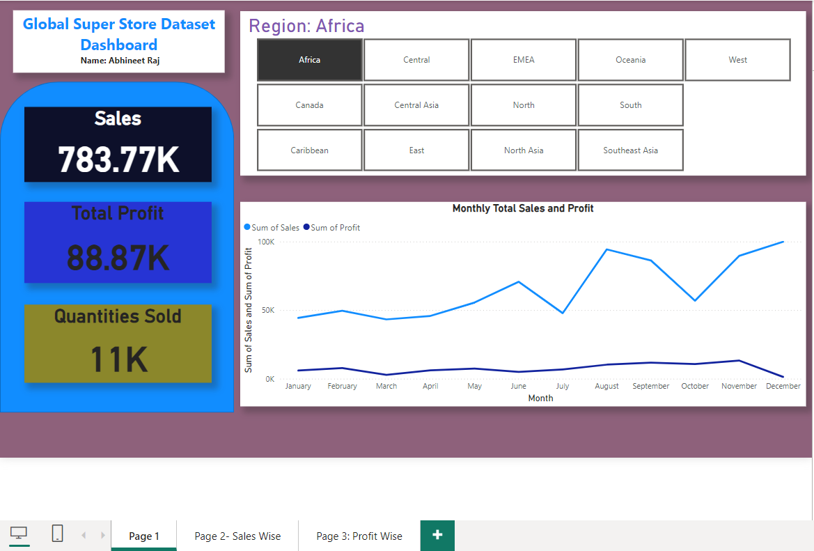

In this dashboard it shows the total sales, profit and quantities sold in the particular region. The user can select the region from the filter menu. The line graph shows the sales and profit amount monthly-wise.

**Dashboard 2:**

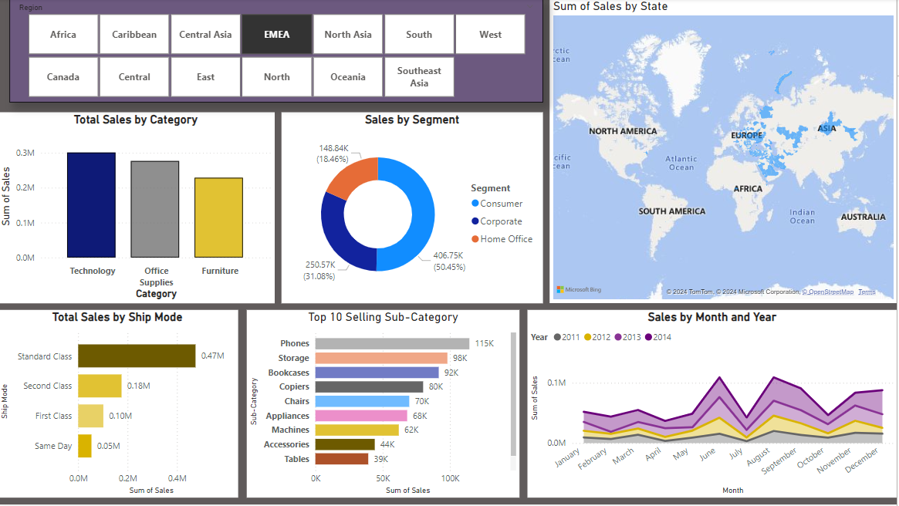

In this we can see different graphs and they are described below:

1. **Total Sales by category**: It shows category wise total sales achieved.
2. **Sales by Segment**: It shows total sales done in each segment of the customer.
3. **Total Sales by Ship Mode**: It shows total sales done in each ship mode of the customer.
4. **Top 10 selling category**: It shows the top 10 sub category item sold.
5. **Sales by Month and Year**: It shows the amount of sales happened in each month and it is done for all individual year.
6. **Map with Profit**

**Dashboard 3:**

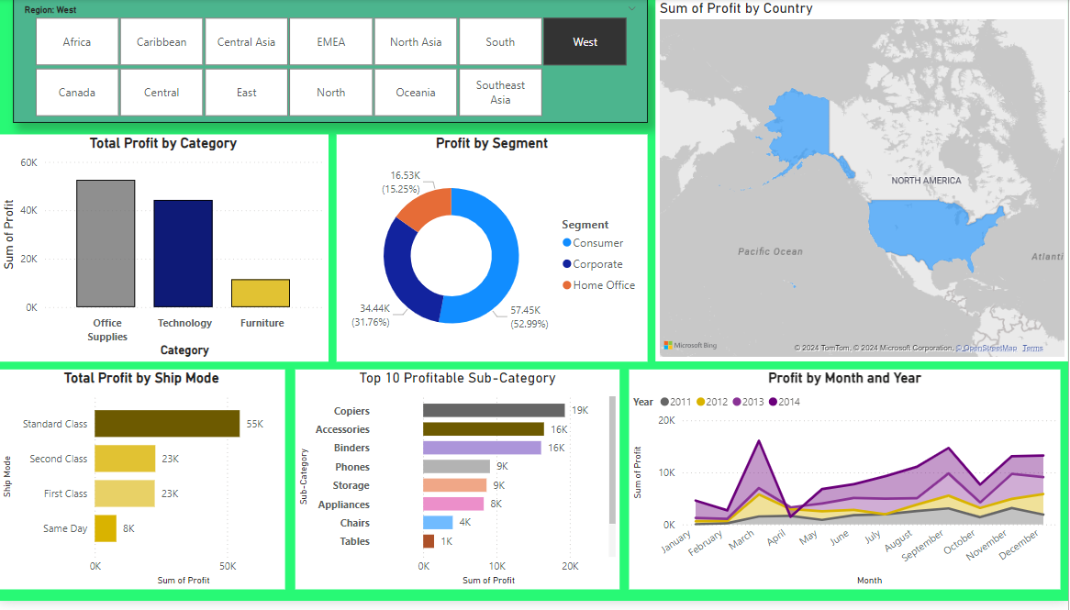

In this we can see different graphs and they are described below:

1. **Total Profit by category**: It shows category wise total profitachieved.
2. **Profit by Segment**: It shows total profitdone in each segment of the customer.
3. **Total Profit by Ship Mode**: It shows total sales done in each ship mode of the customer.
4. **Top 10 Profitable category**: It shows the top 10 profitable sub category item.
5. **Profit by Month and Year**: It shows the amount of profithappened in each month and it is done for all individual year.
6. **Map with Profit**

**In all the dashboard there is facility given thorough the user can filter out the sales and profit according to region wise and by using this user may be able to get the desired result which they needs and proper guidelines can be made for some region to increase the sales and profit.**